MySQL Assignment 2 – Querying Data
Instructions:
★ Continue from the previous assignment (database & table creation with constraints).
★ Use the provided DML insert codes to populate the tables from here: Employee Data
★ Execute the queries in this assignment after inserting the data.
Create DB / Tables
DROP DATABASE IF EXISTS employee;
CREATE DATABASE employee;
USE employee;

CREATE TABLE Departments (
department_id INT PRIMARY KEY,
department_name VARCHAR (100) NOT NULL UNIQUE
);

CREATE TABLE Locations (
location_id INT PRIMARY KEY AUTO_INCREMENT,
location_name VARCHAR (100) NOT NULL UNIQUE
);

CREATE TABLE Employees (
emp_id INT PRIMARY KEY,
emp_name VARCHAR (150) NOT NULL,
gender CHAR (1) NOT NULL,
age INT,
designation VARCHAR (200),
salary DECIMAL (12,2),
hire_date DATE,
department_id INT,
location_id INT,
email VARCHAR (255) UNIQUE,
CONSTRAINT fk_dept FOREIGN KEY (department_id) REFERENCES Departments(department_id)
ON DELETE SET NULL ON UPDATE CASCADE,
CONSTRAINT fk_loc FOREIGN KEY (location_id) REFERENCES Locations(location_id)
ON DELETE SET NULL ON UPDATE CASCADE
);

INSERT INTO Departments (department_id, department_name) VALUES
(1,'Finance'), (2,'HR'), (3,'IT'), (4,'Operations');

INSERT INTO Locations (location_name) VALUES
('Mumbai'), ('Bengaluru'), ('Hyderabad'), ('Chennai');

INSERT INTO Employees (emp_id, emp_name, gender, age, designation, salary, hire_date, department_id, location_id, email)
VALUES
(101,'Asha Rao','F',29,'Financial Analyst',55000,'2015-08-21',1,1,'asha.rao@example.com'),
(102,'Ravi Kumar','M',32,'Data Analyst',48000,'2017-03-12',3,2,'ravi.k@example.com'),
(103,'Meera Singh','F',26,NULL,51000,'2018-06-10',3,2,'meera.s@example.com'),
(104,'Suresh B','M',45,'Manager',90000,'2010-11-01',1,3,'suresh.b@example.com'),
(105,'Priya N','F',24,'Junior Analyst',30000,'2018-02-05',2,4,'priya.n@example.com'),
(106,'Arjun P','M',28,'Business Analyst',70000,'2014-12-15',4,1, NULL);

SELECT * FROM Employees;
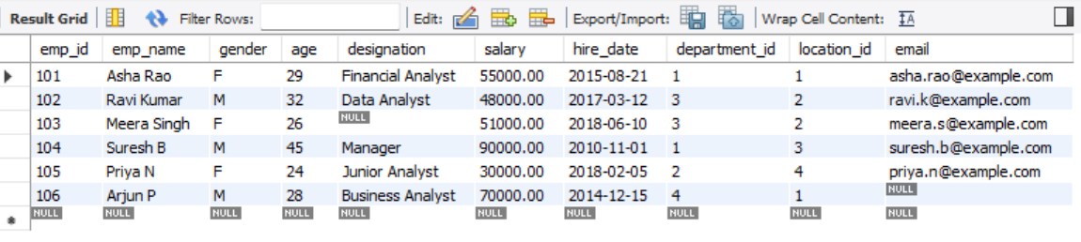

- Distinct Values

⦿ a query to retrieve distinct salaries from the Employees table.

SELECT DISTINCT salary FROM Employees;

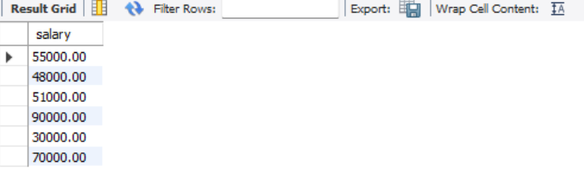

- Alias (AS):

⦿ Provide aliases for the "age" and "salary" columns as "Employee_Age" and
"Employee_Salary", respectively.

SELECT emp_id, emp_name, age AS Employee_Age, salary AS Employee_Salary FROM Employees;

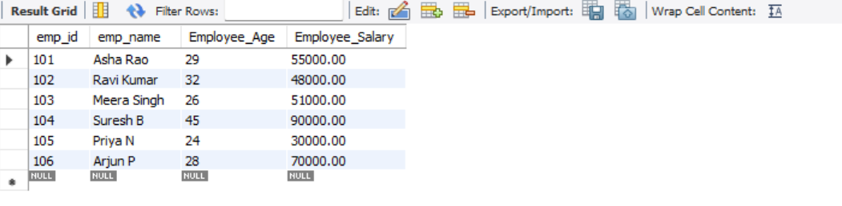

- Where Clause & Operators:

⦿ Retrieve employees with a salary greater than ₹50000 and hired before
2016-01-01.
⦿ Find the employee whose designation is missing and fill it with "Data
Scientist".

SELECT emp_id, emp_name, salary, hire_date FROM Employees
WHERE salary > 50000 AND hire_date < '2016-01-01';

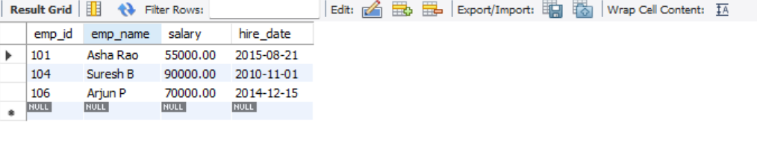

Sorting and Grouping Data:
1. ORDER BY:
⦿ Find employees sorted by department ID in ascending order and salary in
descending order

SELECT emp_id, emp_name, department_id, salary FROM Employees
ORDER BY department_id ASC, salary DESC;

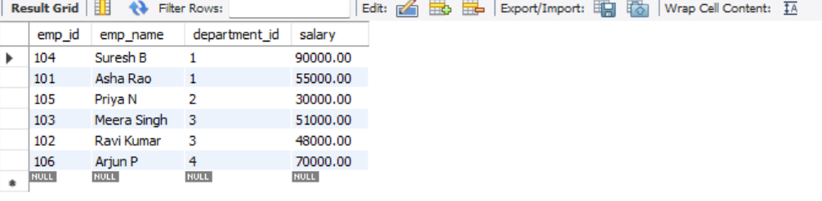

2. LIMIT:
⦿ Display the first 5 employees hired in the year 2018.

SELECT emp_id, emp_name, hire_date FROM Employees
WHERE YEAR(hire_date) = 2018
ORDER BY hire_date
LIMIT 5;

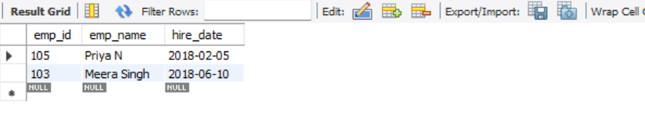

3. Aggregate Functions:
⦿ Calculate the sum of all salaries in the Finance department.
⦿ Find the minimum age among all employees.
SELECT SUM (e. salary) AS total_salary_finance
FROM Employees e
JOIN Departments d ON e.department_id = d.department_id
WHERE d.department_name = 'Finance';

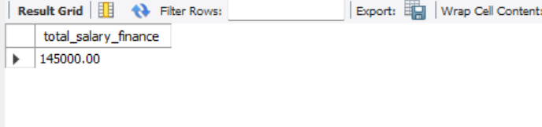

SELECT MIN(age) AS min_age FROM Employees;

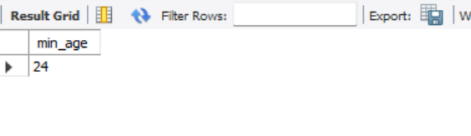

4. GROUP BY:
⦿ List the maximum salary for each location.
⦿ Calculate the average salary for each designation containing the word ‘Analyst'.
SELECT l. location_name, MAX (e. salary) AS max_salary
FROM Employees e
JOIN Locations l ON e. location_id = l. location_id
GROUP BY l. location_name;

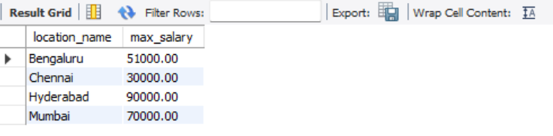

SELECT designation, AVG(salary) AS avg_salary
FROM Employees
WHERE designation LIKE '%Analyst%'
GROUP BY designation;

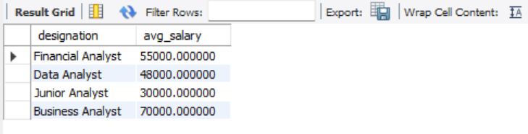

5. HAVING:
⦿ Find departments with less than 3 employees.
⦿ Find locations with female employees whose average age is below 30.

SELECT d. department_name, COUNT (*) AS emp_count
FROM Employees e
JOIN Departments d ON e. department_id = d. department_id
GROUP BY d. department_name
HAVING COUNT (*) < 3;

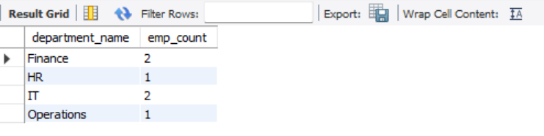

SELECT l. location_name, AVG(e.age) AS avg_age_females
FROM Employees e
JOIN Locations l ON e. location_id = l. location_id
WHERE e. gender = 'F'
GROUP BY l. location_name
HAVING AVG(e.age) < 30;

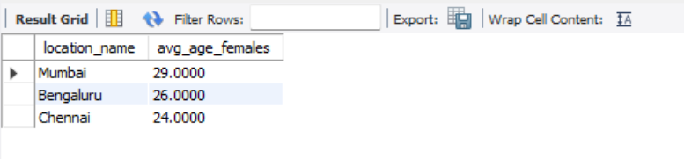

Joins:
1. Inner Join:
⦿ List employee names, their designations, and department names where
employees are assigned to a department

SELECT e.emp_name, e. designation, d. department_name
FROM Employees e
INNER JOIN Departments d ON e. department_id = d. department_id;

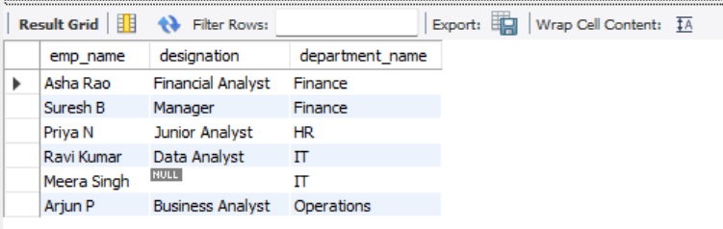

2. Left Join:
⦿ List all departments along with the total number of employees in each
department, including departments with no employees.

SELECT d. department_name, COUNT(e.emp_id) AS total_employees
FROM Departments d
LEFT JOIN Employees e ON d. department_id = e. department_id
GROUP BY d. department_name;

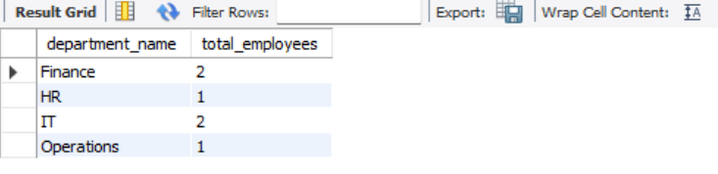

3. Right Join:
⦿ Display all locations along with the names of employees assigned to each
location. If no employees are assigned to a location, display NULL for employee name.

SELECT l. location_name, e.emp_name
FROM Employees e
RIGHT JOIN Locations l ON e. location_id = l. location_id
ORDER BY l. location_name;

